A+ Computer Science Shrek’s Adventure Lab Value - 100

Lab Goal: This lab was designed to help you understand how ifs/elses, loops, ands, ors and negations work. The main goal is to get Shrek and donkey to save Fionna from her castle, as well as bring her back to the kingdom. On your journey you will encounter many nets, flowers, and water that must be avoided.

Lab Description: Fionna is stuck in her castle, and it is up to Shrek and Donkey to rescue her and bring her back to the kingdom. But in order to rescue their fair maiden, Shrek and Donkey must traverse through a very confusing maze. In order for them not to get lost they must drop a trail of flowers through their path. And on their journey back, they must pick up the flower trail that they made. But watch out, this journey is not a simple walk through the park there is an evil dragon guarding the
Files Needed:

JerooProject.jsc
ProjectIsland.jev
castle. If either Shrek or Donkey are hurt by the dragon,
the journey will be over.

Starting Screen:
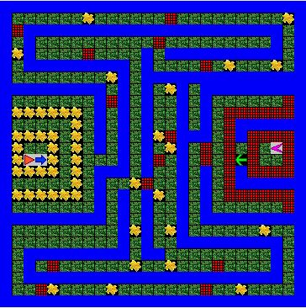
algorithm help

Preconditions
- Is there a Flower/Net/Water?
- Is it clear to move ahead?
- What direction do it turn?
- Should I stop?

Postcondition
- Successful hop through the maze
- Jeroo is not in the Water/Net
- Jeroo stops facing other Jeroos
- Did the Jeroos finish in the original position facing West?
- Did Shrek and Donkey successfully rescue Fionna?

Ending Screen:
